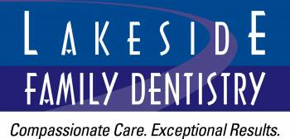
1880 W. Wayzata Blvd.
Long Lake, MN 55356

www.lakesidedentistrymn.com

CONTACT US TODAY FOR AN
APPOINTMENT!

(952) 475-0989

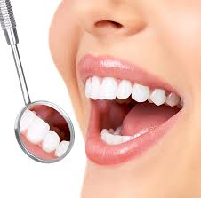
Your DENTAL
SAVINGS plan

Smile Smile Advantage Progra Advantage

Program™

NO Insurance? NO Problem!



BENEFITS OF OUR PROGRAM OVER TRADITIONAL INSURANCE

- No paperwork
- No pre-authorizations needed
- NO MAXIMUMS per year
- Can cancel at any time
Plans include the following services for one FULL YEAR:

Professional cleaning and polishing
-2 per year. (excludes perio scaling and root planing)
Dental exams
-2 per year.
Emergency exam
-1 per year.
X-rays
-all necessary x-rays per year. (excluding CBCT)
Fluoride treatments
-1 per year. No age limitation.
Free TEETH WHITENING for LIFE!

PLUS:
15% OFF all your RESTORATIVE and MAJOR SERVICES including fillings, crowns, dental implants and other oral surgery
(some exclusions may apply)

INDIVIDUAL PLAN
$325 per year

$285 per year if age 13 or younger

INDIVIDUAL + ONE
$615 per year

FAMILY PLAN
(up to 4 individuals)
$1200

*15% off does not apply towards purchase of Invisalign, dentures or “botox” services.

FREE

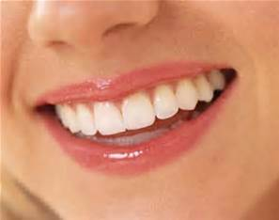

FREE TEETH WHITENING!

